Abbeyfield School
Ambitious to Achieve

Assistant Principal Post – Behaviour and Attitudes

Our Values

Respect
Resilience
Honesty
Responsibility
Creativity
Independence

Dear Colleague
Thank you for your interest in the post of
Assistant Principal of Abbeyfield School.
I joined Abbeyfield School as Principal in September 2018 and feel very privileged to be part of a community of committed staff and rewarding young people. Teamwork is central to the culture of the school and through this and a shared desire to support and challenge every student in order for them to achieve their personal best we are building on the 2016 Ofsted ‘good’ judgement and our very pleasing recent outcomes. We have very high expectations and aspirations of ourselves and of our students. Our Quality First Teaching Charter ensures a focus on high quality teaching and learning supported by an ambitious programme of pedagogical and subject specific CPD. As important as academic achievement is our role in students’ social and personal development, equipping them with the life and employability skills needed for successful adulthood.
Abbeyfield School is looking for an ambitious, experienced, committed and energetic leader who shares our vision and values and can support the aims and ethos of the school and Creative Education Trust. This is an exciting opportunity to work with myself and my team to make a significant difference to the next stage of our journey. There is a real commitment to professional development within the school and the Trust making this is an ideal post for a colleague with aspirations to become a Vice-Principal.
We, like all schools in the Trust pursue a rigorous and continuous programme of educational improvement, alongside an aim to provide pupils with a rich programme of co-curricular activities. Abbeyfield offers a varied diet of curriculum and enrichment opportunities and students benefit from Trust organised events such as the key concept launch days, debate and essay writing competitions and our annual days of Shakespeare performance. We are often the host school for these events to allow students from all trust schools to work in a professional theatre space. We are keen to expand further on the opportunities we provide for students to develop their creativity, resilience and independence.
High expectations for behaviour for learning is supported by a strong team of Year Heads and a behaviour team of non-teaching staff. There is a strong emphasis on restorative justice and positive behaviour management alongside our praise and consequence pyramids.
I am passionate about students, staff and parents having the opportunity to influence the future of the school and contribute to our improvement agenda. ‘Ambitious to Achieve’ was proposed by a Year 12 student and our new school values were the outcome of a students and staff vote. Stakeholder feedback is regularly sought and informs our strategic leadership.
We believe Abbeyfield is a very special place to work and we are excited about the future. If you are passionate about what we are trying to achieve and you can make a real difference in this role then I look forward to receiving your application. Pre application visits or conversations are encouraged.
Please complete the application form and include a letter of application (Maximum 2 sides of A4), evidencing how your skills and experiences would enable you as AP, to make a significant contribution to the next stage of our journey.
Kind Regards,

Siona Robson, Principal

#teamabbeyfield

- Raise their attainment in exams and tests through outstanding teaching
- Make them intellectually curious with a sense of confidence
- Increase their participation in HE, FE and apprenticeships
- Ensure they have employable skills and attitudes
- Create rounded individuals through a wide choice of co-curricular activities
ABOUT
CREATIVE
EDUCATION
TRUST

Creative Education Trust inspires and enables young people to build successful lives on foundations of learning, resilience and employability. We believe that a rewarding educational experience and the highest possible qualifications are the best way to ensure social mobility for young people.
Creative Education Trust is a growing multi-academy trust educating over 13,000 children in England. It was established in 2010 and has successfully transformed schools in England’s post-industrial cities and coastal towns: areas of economic disadvantage and with a history of academic underachievement.
Creative Education Trust defines creativity as the ability to find connections between the things we know and turn these connections into new ideas and action. The academic arts and the sciences, practical subjects and life skills all need this creativity, and creativity is valued highly by employers. Our unique Knowledge Connected approach teaches pupils to analyse and understand their curriculum of study through the application of six key concepts.
Educational rigour
Organisational effectiveness
Financial efficiency
Partnership & recognition of local identity
Respect for autonomous leadership
Quality not quantity
Promoting practical creativity
You can watch a short video on what it means to be part of Creative Education
Trust, illustrating our ‘Knowledge Connected’ approach to learning.
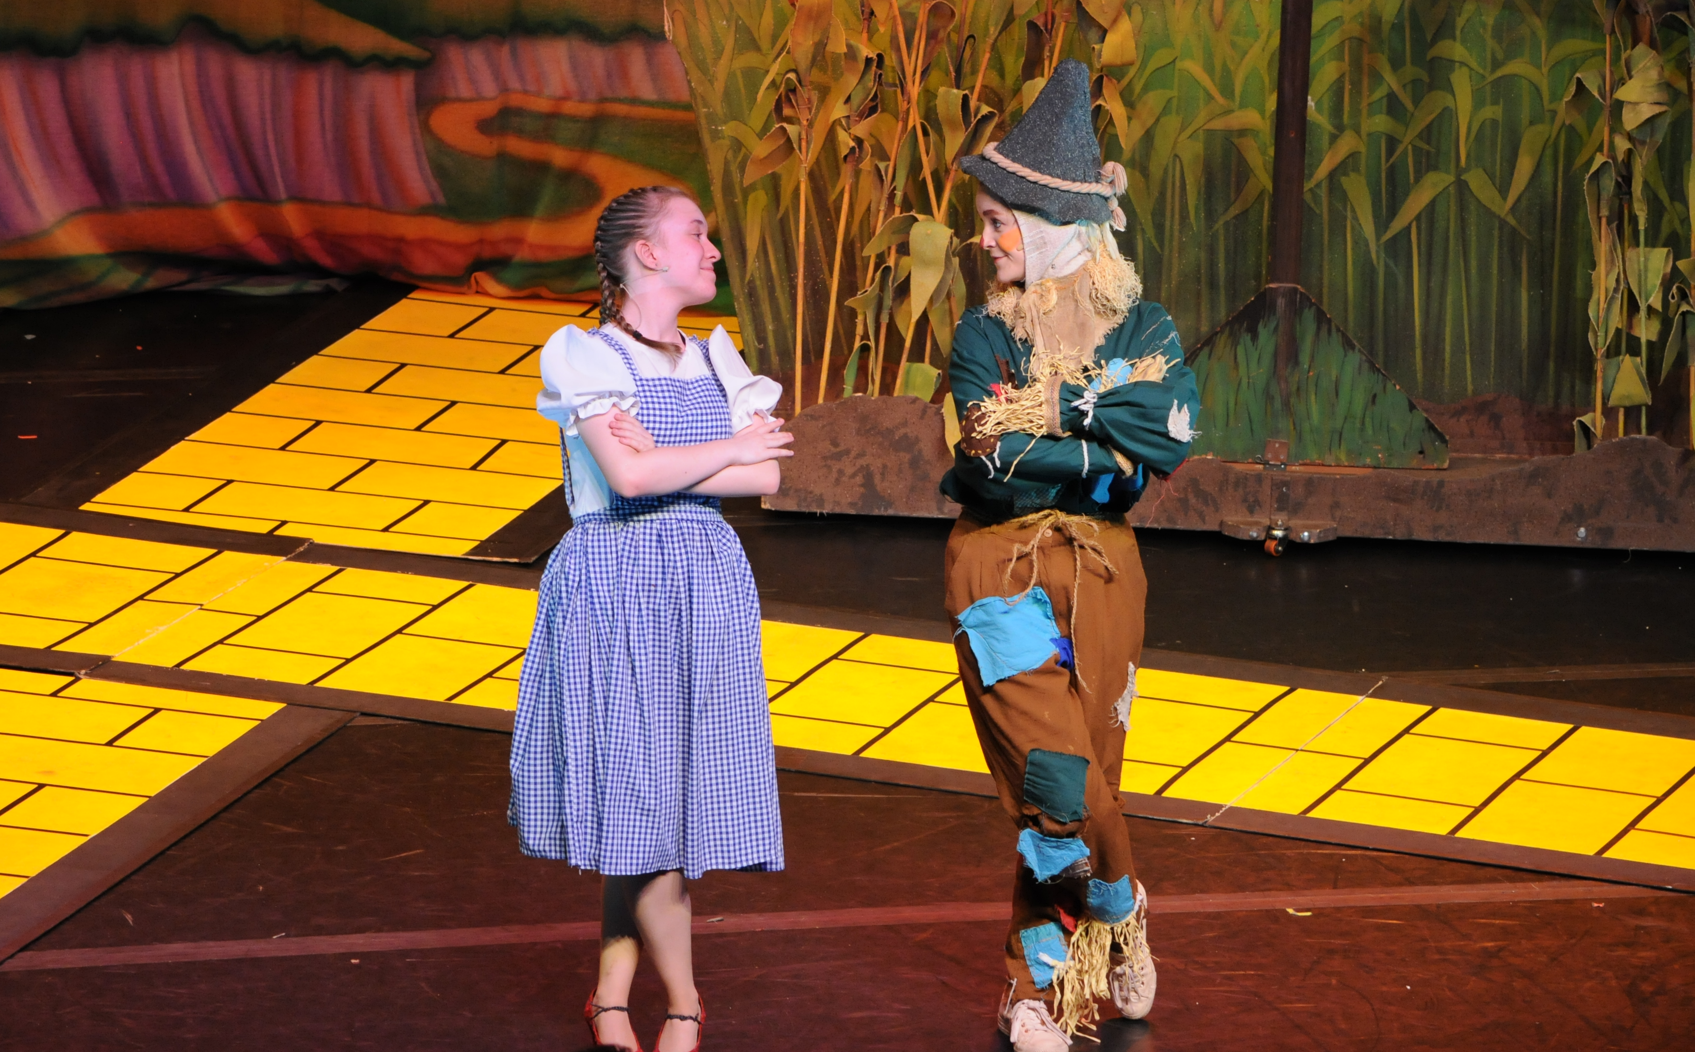
www.youtube.com/user/creedacad.

Northamptonshire School of the Year.
‘It goes to a school that is at the start of a new era, one who has just set out a new vision and values which were voted on by the students.’ ‘The tour from students was honest and their passion and belief in what you are trying to achieve was undoubtedly sincere’ (Judges comments).
To see details of the school performance data please visit:
https://www.compare-school-performance.service.gov.uk/school/138858/abbeyfield-school
ABOUT
ABBEYFIELD
SCHOOL

We are a popular and oversubscribed mixed secondary school, catering for children between the ages of 11 and 18 years located in Northampton.
Since September 2012 we have been part of the Creative Education Trust. This has enabled the school to rigorously pursue rapid improvement for the children we teach.
The school boasts outstanding facilities in a modern well-kept stimulating environment.

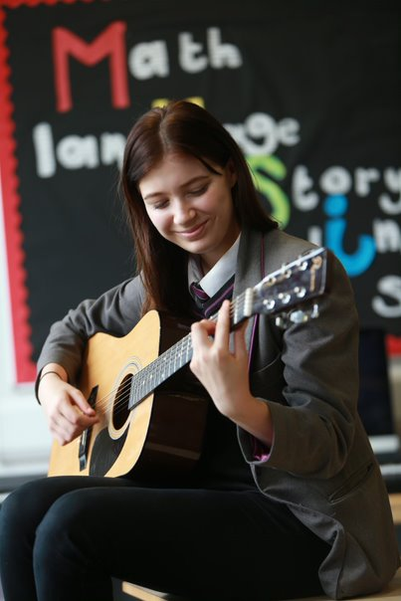
Our facilities include:
- Sports fields, netball courts, basketball courts, a gym and full size sports hall
- Use of Goals, a purpose built 5-a-side football venue
- Fitness Suite with sound system
- Dance studios with sound system and mirrored walls
- Super Learning Centre providing the opportunity for collaborative teaching and learning
- Science Lecture Theatre for demonstrations or large group activities
- Professional 280 seat Theatre complete with tiered seating
- Interactive whiteboards in every classroom
- Modern, glass fronted, open-plan learning resource centre
__________________________________________________________________
- Accommodation available for staff with a number of ensuite rooms

SUPPORT
FOR OUR
STAFF

We are committed to providing our staff with the highest quality
support and challenge to ensure that we excel and give our students
the opportunities and provision they deserve. Senior leaders are
encouraged where possible to sit on the academy council of another
CET school which is a very valuable experience.

Each of the Creative Education Trust’s schools benefits from a comprehensive programme of support and challenge, including working with former HMIs.

Creative Education Trust places a strong emphasis on CPD for teachers and for senior and middle leaders. They run a regular programme of training events to improve teaching performance and also provide focused management development and one-to-one coaching opportunities. There is an active cross-trust group on the Teaching Leaders programme and use Future Leaders and Teach First extensively.
The school is supported by an experienced Head Office team, who are available to advise on financial planning, audit, HR, legal and property matters either directly or by referral to our professional advisors.
There are also a number of cross-group, phase leader and year-specific forums to facilitate collaboration across the schools.

ASSISTANT PRINCIPAL
JOB DESCRIPTION

LOCATION
Abbeyfield School, Northampton

SALARY
L12 - L16

THE ROLE
The Assistant Principal will provide the leadership required to work with Senior Colleagues and Middle Leaders to achieve excellence in terms of students’ behaviour and attitudes.
The key strategic responsibilities are expected to be:
- Behaviour for Learning
- Culture and attitudes
- Curriculum Enrichment
- Stakeholder engagement
- Student voice and leadership
- Quality of pastoral care

(Please note these are subject to discussion with the successful candidate and will be reviewed as appropriate to maximise the strengths of the SLT)

REPORTING LINES
The post will report to a Vice Principal

STRATEGIC DIRECTION AND DEVELOPMENT

- Make a significant contribution to the development, communication and implementation of the vision for the school

- Promote and uphold the values and ethos of the school and Creative Education Trust such that the highest achievements are expected from all members of the school community.

- Formulate, devise, agree and monitor improvement plans to maximise impact.

- Lead and manage successful change across the school.
___________________________________________
- To lead on strategic areas of school improvement and be able to demonstrate impact of this.

LEADING TEACHING AND LEARNING

- Make a significant contribution to ensuring high quality teaching and learning across the school leading to good or better academic progress for students.

- Promote the development of students’ moral, spiritual, physical and social progress.

- Drive innovation in education, ensuring the school is able to respond to a changing external environment and that the skills, learning and aspirations of children and young people are developing and enhanced at all key stages.

- Monitor, evaluate and review classroom practice; celebrate and promote excellence, challenge under-performance at all levels and ensure appropriate action is taken in accordance with policies and procedures.

LEADERSHIP OF PEOPLE

- Provide exemplary leadership for the whole school community acting as a role model for staff and students.

- Ensure a high level of presence around school and promote high staff morale and ownership of the school’s values and policies.

- Contribute to the provision of high-quality training and development for all staff which empowers staff at all levels to lead and initiate improvements.

- Develop high-quality leadership in both academic and pastoral areas through effective line management of middle and senior leaders.

- Manage staff performance and conduct effectively and resolve complaints.

STUDENT WELFARE, BEHAVIOUR AND ATTITUDES AND PERSONAL DEVELOPEMENT

- Ensure high-quality pastoral care so that behaviour and attitudes are outstanding supporting all students fulfil their potential.

- Ensure students are all informed about curriculum attainment and progress and are able to understand targets and improvements.

- Ensure good behaviour around school and in lessons is maintained and staff expectations are high and establish a culture of praise and consistent applications of consequences

- Proactively promote an atmosphere of respect, recognition, celebration and mutual support in the school.

- Maintain an environment which feels safe and enables students to report any concerns or complaints.
- Work in collaboration with external agencies to ensure we are working within all legal guidelines and offering the best support to our students.

RESOURCE MANAGEMENT

- Be accountable for the management of any devolved budget.

- Manage aspects of the organisation as requested to ensure that accommodation is used effectively and efficiently in order to achieve a positive learning environment.

- Promote the highest achievement for all alongside value for money.

- Maximise the acquisition and use of grants and other fund-raising opportunities as required.

GOVERNANCE

- Advise and report to Creative Education Trust Board, Executive Directors and the Academy Council, as appropriate to the agreed responsibilities, to ensure strong accountability.

- Support the Principal to ensure that statutory requirements are met and policies of the Trust are implemented.

PARTNERSHIPS AND PROMOTION OF THE SCHOOL

- Support partnership working, particularly with sister schools within Creative Education Trust, to ensure that this is a strength of the school and enhances the opportunities available to students.

- Present a coherent and accurate account of the delegated areas of responsibility in a form appropriate to a range of audiences.

- Support the successful transition for all students.

- Actively support and establish links with other learning establishments and employers and training providers to maximise opportunity for students.

- Maintain a high-profile image of the school in high quality public presentations.

SCHOOL ETHOS AND COMMUNITY

- Ensure effective communication with all stakeholders in the school community (including parents) so that they are kept informed about, consulted on, and have an understanding of the aims of the school, its policies and procedures and future direction.

- Support solutions to achieving the British values of diversity, dignity and equality in all aspects of service delivery and engagement with the broader community.

- Actively foster a culture where all members of the school community respect others and their physical surroundings.

- Support the personal development of all students and contribute to maintaining a caring climate in which self-confidence, self-respect and social responsibility are encouraged.

- Develop amongst teaching staff an outward perspective and desire to contribute to wider life of the school.

SUPPORTING THE WORK OF CREATIVE EDUCATION TRUST

- Develop strong, positive relationships with Creative Education Trust colleagues; contribute to collaborative work across Creative Education Trust schools and support other staff in participating in trust-wide work and projects.

- Participate in Creative Education Trust and sector-wide activities in order to share best practice and promote the school and Creative Education Trust in a national context.

- Undertake any other reasonable duties deemed appropriate to the role of an Assistant Principal

PERSON SPECIFICATION

 | ESSENTIAL | DESIRABLE
QUALIFICATIONS | Good honours degree  Qualified teacher | NPQSL  Further qualifications and/or professional studies relevant to the age-range
EXPERIENCE | Substantial and successful experience in secondary school middle leadership.  - Track record of raising educational standards.  - Experience of establishing, maintaining, and promoting outstanding behaviour and attitudes  - Successful experience of using target setting, data analysis and curriculum innovation to improve performance.  - Evidence of promotion of innovation in teaching and learning.  - Demonstrable success in leading on the development, implementation, and evaluation of improvement plans which had demonstrable impact.  - A strong track record of working successfully with the local community and support agencies.  Proven experience as an excellent teacher | Experience of successful KS5 teaching  Experience of more than one school
KNOWLEDGE AND  UNDERSTANDING | - An in-depth understanding of school leadership and the school improvement strategies needed to achieve outstanding behaviour and attitudes, student progress and personal development.  - Knowledge of current education legislation, national strategies, trends and innovation.  - The ability to develop a philosophy of high aspiration and expectation for every student giving cognisance to SEND, equal opportunities, diversity and ethos.  - The ability to analyse data, identify issues and trends and address identified areas for improvement.  - Understanding of all relevant accountability frameworks. | .
SKILLS AND  PERSONAL  ATTRIBUTES | High expectations of self and others.  Resilience and motivation to manage day-to-day challenges and ability to find creative solutions to problems and resolve conflict effectively.  Proven ability to lead, coach and motivate staff within a performance management framework, including professional development and effective management of underperformance.  Strong organisational skills and the ability to delegate.  Effective and skilled at implementing systematic behaviour management systems with clear boundaries, sanctions, rewards and praise.  Relishes accountability and takes personal responsibility for their own actions.  Ability to inspire and motivate large groups of staff, students or parents.  Excellent critical thinking skills; creative approach to problem solving, intellectual curiosity and rigour.  - An ability to enthuse and engender a desire for learning and passionate commitment to excellence at all levels.  - Ability to provide inspirational leadership with a sensitivity and wisdom in managing effective relationships with students, families and staff.  - Commitment to inclusive education providing opportunity for achievement for all.  - Integrity, openness, energy and enthusiasm.  Strong interpersonal, written and oral communication skills.
EQUAL  OPPORTUNITIES | A demonstrable commitment to supporting and promoting safeguarding, student welfare, equality and diversity.
SAFEGUARDING | A thorough understanding of up-to-date safeguarding requirements and best practice.
OTHER  REQUIREMENTS | High expectations for every pupil and a proven track record of making a difference to the learning and experiences of pupils inside and outside the classroom.
Creative Education Trust is committed to safeguarding and promoting the welfare of our children and young people and expects all staff and volunteers to share this commitment. The successful applicant will be required to undertake relevant safeguarding checks in line with Government safer recruitment guidelines.

